|  |  |  |  |  |
| --- | --- | --- | --- | --- |
|  |  |  | 3 MARCH 2022 | |
| NUMERICAL COMPUTING (CS325) | | | | |
|  | | | | |
| Course Instructor:  Sir Jamil Usmani | |  |  |  |

**NUMERICAL COMPUTING (CS325)**

**PROJECT**

**LAB – 1**

**Group Members:**

* Mohammad Basil Ali Khan (20K-0477)
* Ali Jodat (20K-0155)
* Abdul Ahad Shaikh (20K-0319)
* Mohammad Umer (20K-0225)

**Project Title:**

**LAB 2: Interpolation and Polynomial Approximation**

**Aim:**

To understand the fundamental concepts of scientific programming using python.

**Description:**

We selected three methods of Lab1.

1. Lag grange Interpolation
2. Newton Divided Difference

First we have studied the algorithm of then we have written the programming of that method.

**IDE and Programming Language:**

We have chosen python programming language and IDE we are using is Visual Studio Code.

**Library Used:**

* Used panda library to make data frame

**Implementation and Code Snippets:**

* **Lag grange Interpolation:**

**Formula:**

$$f\left(x\right)= f_{0}∂_{0}\left(x\right)+ f_{1}∂_{1}\left(x\right)+ f_{2}∂_{2}\left(x\right)+…+ f_{N}∂_{N}(x)$$

Where $∂_{i}\left(x\right)$ can be written as;

$$∂_{i}\left(x\right)= \frac{\prod_{i=0}^{N}{;i≠j}(x-x_{j})}{\prod_{i=0}^{N}{;i≠j}(x_{i}-x_{j})}$$

**Algorithm:**

Step 1: Read number of data N.

Step 2: Read data Xi and Yi from I = 0 to I = N.

Step 3: Read value of independent variables say x whose corresponding value of dependent say y is to be determined.

Step 4: Initialize: y = 0

Step 5: For i = 0 to N

Set p = 1

For j =0 to N

If i ≠ j then

Calculate product = product * (x - Xj)/(Xi - Xj)

End If

Next j

Calculate y = y + product * Yi

Next i

Step 6: Display value of y as interpolated value.

**Code Snippets:**

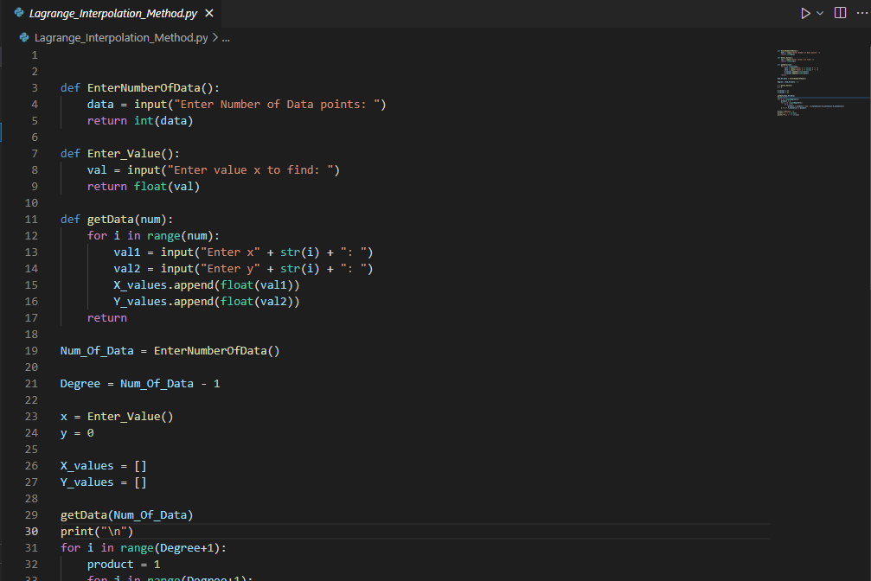

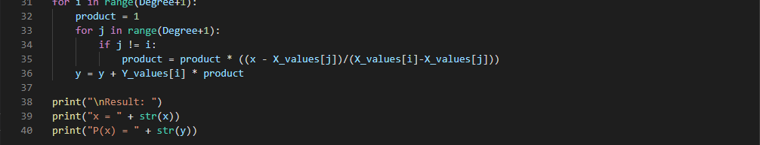

**Output:**

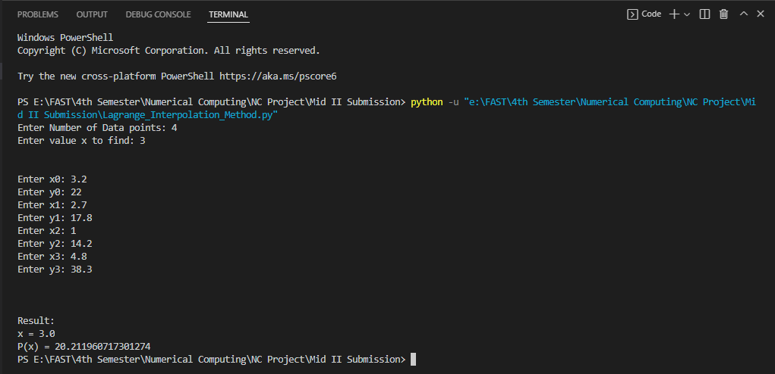

* **Newton Forward and Backward:**

**Formula:**

* **Forward**
$$P_{n}\left(x\right)= \sum_{i=0}^{n}{\left({p \atop i}\right)∆^{i}f_{i}(x)} ;p= \frac{x- x_{0}}{h} ;h= x_{1}- x_{0}$$

* **Backward**

$$P_{n}\left(x\right)= \sum_{i=0}^{n}{\left({p \atop i}\right)∇^{i}f_{i}(x)} ;p= \frac{x- x_{n}}{h} ;h= x_{1}- x_{0}$$

**Algorithm:**

* **Forward**

Step 1: Read number of data (n)

Step 2: Read data points for x and y:

For i = 0 to n-1

Read Xi and Yi,0

Next i

Step 3: Read calculation point where derivative is required (xp)

Step 4: Generate forward difference table

For i = 1 to n-1

For j = 0 to n-1-i

Yj,i = Yj+1,i-1 - Yj,i-1

Next j

Next i

Step 5: Calculate finite difference: h = X1 - X0

Step 6: Set sum = 0 and sign = 1

Step 7: Calculate sum of different terms in formula to find derivatives using Newton's forward difference formula:

For i = 1 to n-1-index

term = (Yindex, i)i / i

sum = sum + sign * term

sign = -sign

Next i

Step 8: Divide sum by finite difference (h) to get result first_derivative = sum/h

Step 9: Display value of first_derivative

* **Backward**

Step 1: Read number of data (n)

Step 2: Read data points for x and y:

For i = 0 to n-1

Read Xi and Yi,0

Next i

Step 3: Read calculation point where derivative is required (xp)

Step 4: Generate backward difference table

For i = 1 to n-1

For j = n-1 to i (Step -1)

Yj,i = Yj,i-1 - Yj-1,i-1

Next j

Next i

Step 5: Calculate finite difference: h = X1 - X0

Step 6: Set sum = 0

Step 7: Calculate sum of different terms in formula to find derivatives using Newton's backward difference formula:

For i = 1 to index

term = (Yindex, i)i / i

sum = sum + term

Next i

Step 8: Divide sum by finite difference (h) to get result

first_derivative = sum/h

Step 9: Display value of first_derivative

**Code Snippets:**

* **Forward**

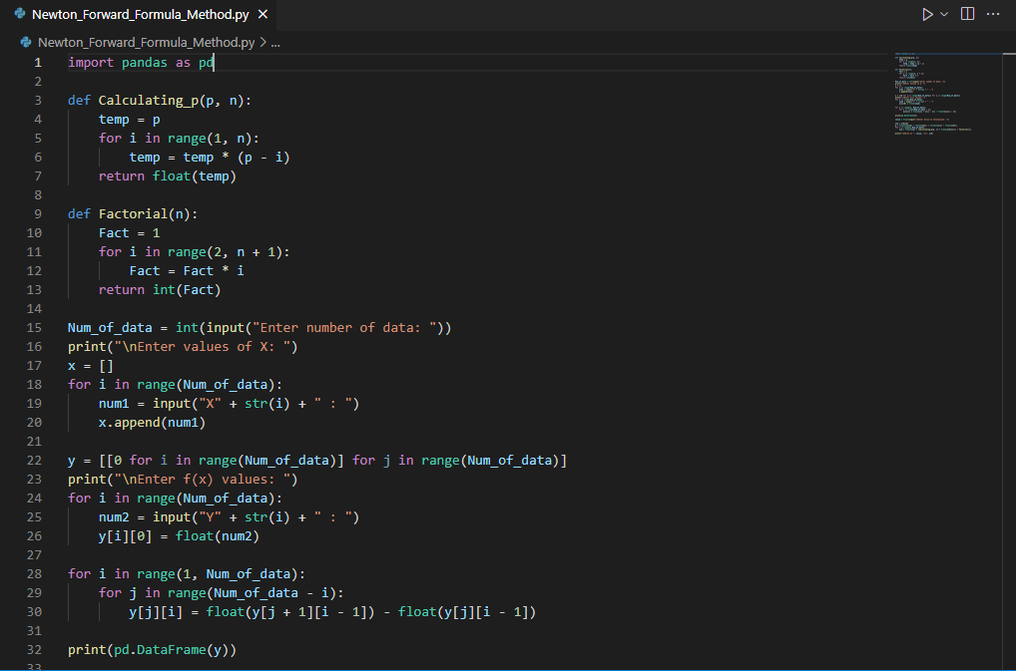

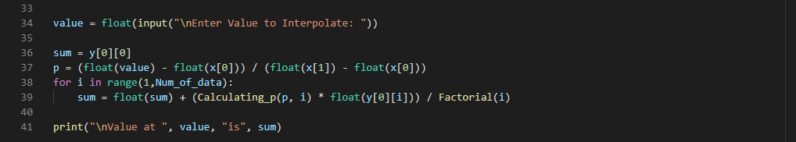

* **Backward**

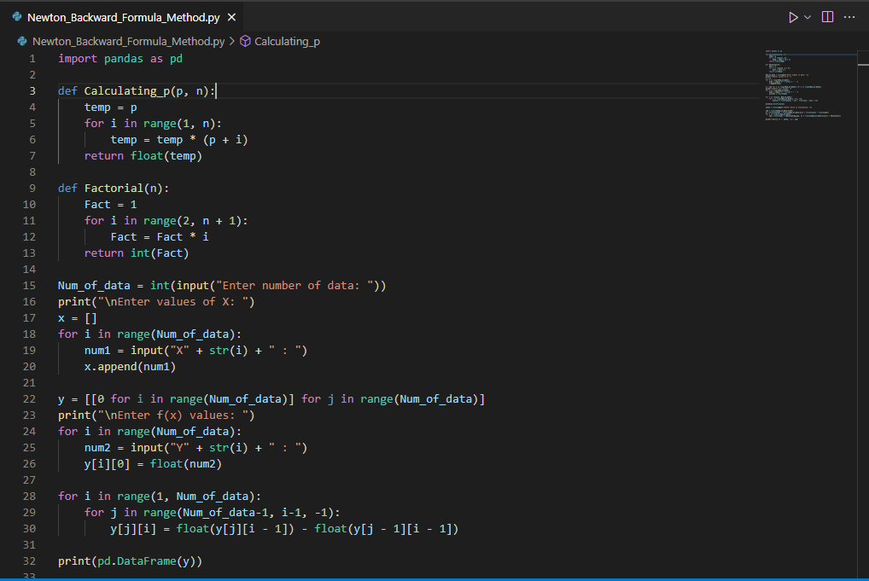

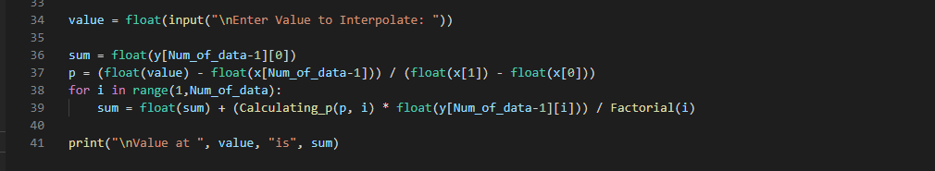

**Output:**

* **Forward**

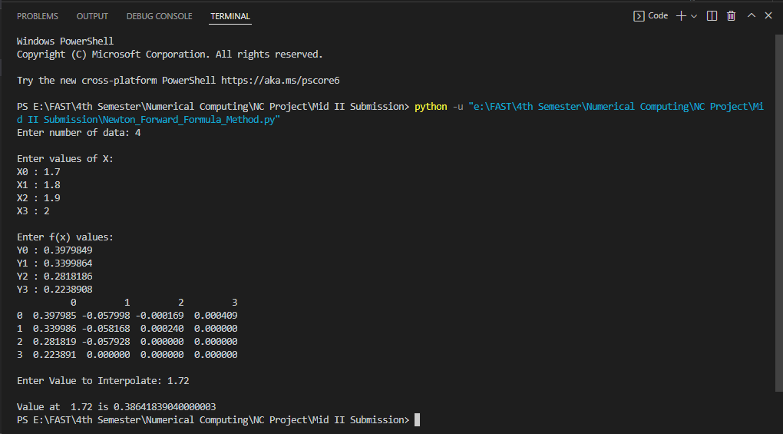

* **Backward**

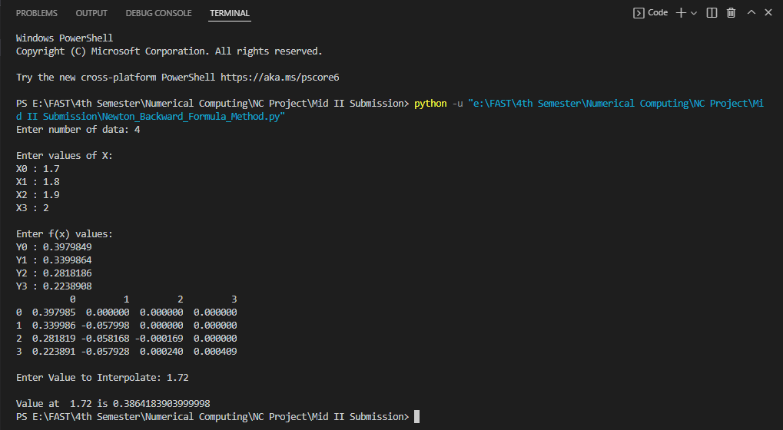

**Iske aagay apna krle Jodat**